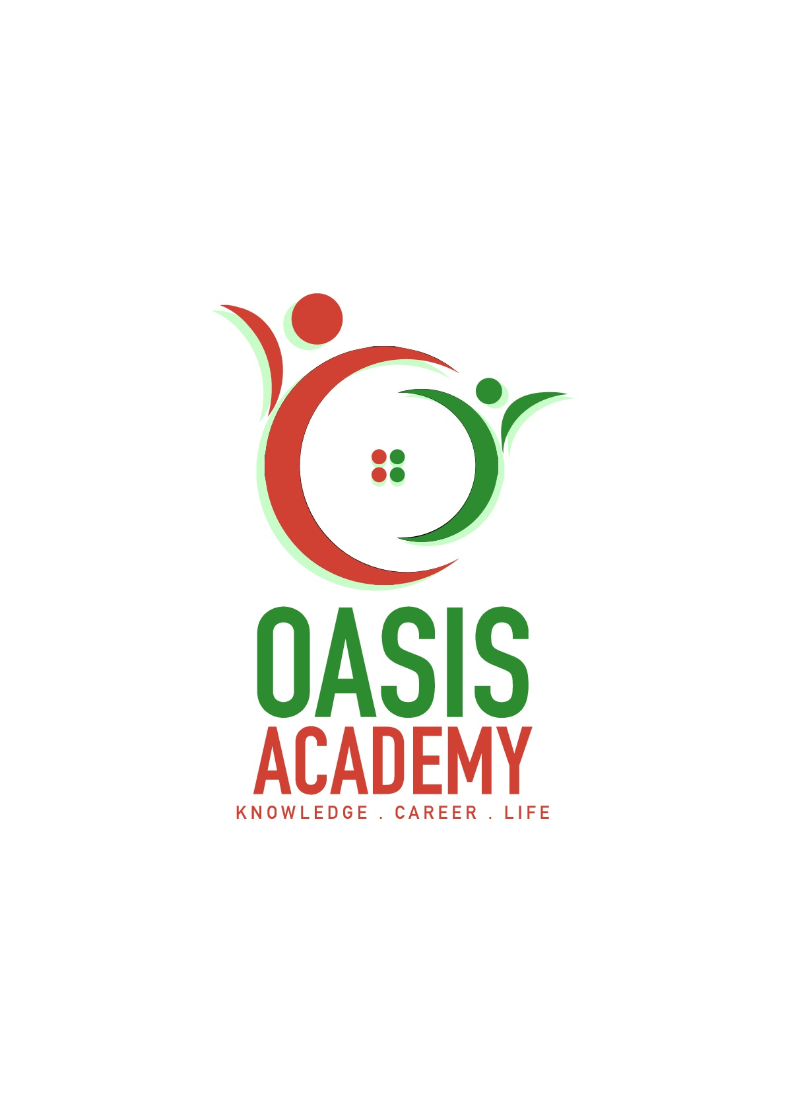

**NAME :** RYAN MAH SONG WENG

**LOGIN ID :** mahsongweng@oasis-portal.my

**COURSE TITTLE :** Executive Diploma In Hospitality Management

**SUBJECT CODE :** DHM01

**CONTENTS**

|  |  |  |
| --- | --- | --- |
| **NO** | **CONTENTS** | **PAGE** |
| 1. | Executive Summary | 1 |
| 2. | Introduction | 2 |
| 3. | Part 1  3.1 The Principle of Tourism and Hospitality  3.2 Understanding about Hospitality Industry | 3 - 4  5 - 6 |
| 4. | Part 2  4.1 Define Tourism  4.2 Types of Tourism | 7  7 - 9 |
| 5. | Part 3  5.1 The Lodging Accommodation  5.2 Types of Hotel Accommodation | 10  10 - 13 |
| 6. | Part 4   * 1. Significance of Entertainment in Hospitality Industry | 14 - 15 |
| 7. | Appendix | 16 - 26 |
| 8. | References | 27 |

1. **EXECUTIVE SUMMARY**

In the module, I covered the topic about Principal of Tourism and Hospitality. In assignment part, I have introduction of tourism and hospitality. In first part, I explain about the principle of tourism and hospitality and understanding about hospitality industry. In second part, I define meaning of tourism and types of tourism. In third part, I describe the lodging accommodation and types of hotel accommodation in hospitality and tourism industry. Lastly, I will explain the significance of entertainment in hospitality industry. I will give some appendix and references in this assignment for more clearly understanding about the hospitality and tourism.

**2.0 INTRODUCTION**

What is Hospitality? Hospitality industry is incorporate different businesses and addition of tourism industry to provide service to customer which include restaurants and food, beverage services, lodging, travel and tourism. Hospitality industry is the largest industry in the world. It is the main source of income for majority countries. Hospitality is not just about a simple servicing, but it involves in showing respect for one's guests, provide for their needs and wants, and treating each other as equals.

In hospitality industry always focus on difference customer satisfaction, such as leisure tourism, cultural tourism, religious tourism, family tourism, health tourism, sport tourism, education tourism, business tourism and alternative form of tourism. Every tourism go for travel with difference purpose. While entertainment industry is a key category of the hospitality industry as it involves the most important thing of hospitality which lead the traveler experience and enjoy their fun time.

The hospitality industry in every countries should be able to provide and meet the difference needed of customers which may provide an excellence and quality service. In addition, the hospitality industry has lead lots of benefits to every countries. So the government should support the industry to maximize productivity to satisfy everyone’s demand.

1. **PART 1**

**3.1 THE PRINCIPLE OF TOURISM AND HOSPITALITY**

Tourism known as a temporary short-term movement or activities of visitor to stay at a travel destination away from their living and working places for more than 24 hours. While, according to Mathieson and Wall (1982) (Appendix 3.1), tourism is a facilities to cater the people needs when they have a temporary movement more than one day from their usual environment to stay at a travel destination.

There are different perspectives of tourism by Mcintosh and Goeldner (1990) (Appendix 3.2):

For tourist, tourism is a facilities to cater their needed when they have a visit to the travel destinations and have activities for more than a day. For examples, traveler choose travel to all around the world (Appendix 3.3) to seek of various psychic and physical experience of nature environment. Different travel destination will show different experience and enjoyment for the tourist.

For business, tourism is an opportunity to earn profit by supplying the needs of traveler such as goods and services. For example, traveler will buy lots of souvenir as a memorial. Some of the traveler will buy lots of native products and give it to relative or friends. While this services is intangible and can’t be expected because the goods and service is vary time to time.

For government of the host community or area, tourism is a wealth factor which make a big contribute in economy of the country. When the international tourist travel in our country, income earning from foreign exchange receipts, tax receipts and expenditures from international tourist directly through different promotion to attract them.

According to dictionary, hospitality refer to serving people with warm welcoming, kind, generous and friendly treatment towards visitors or strangers. Hospitality professionals generally work in hotel and restaurant industries. They are giving professional training to create an exceptional customer service to let their customer feel that they are welcomes and comfortable when they visit to hotel and restaurant.

Majority of people consider that hospitality and customer service are same. Actually hospitality and customer service have lots of same rules between each other like serve customer cater to their needed but they are different. Customer service refer to provide help to someone which is encompasses with business. We can feel different experience in these two service.

When the traveler visit a hotel or restaurant, there is a staff will open the door with a friendly smile and greeting to visitor such as good morning. At the counter, the worker will automatically greeting to their customer such as welcome. They will ask and check out what do the customer need. This may give a positive experience to their customer because they are always being polite and ready to assist if necessary.

In contrast, the customer will get the negative experience when they walk in a store. For example, there are no one welcome and greeting with u when visit to their store. You are not giving service and conversation when you are finding something in the store. They try to serve when u ask for help from them. Obviously, hospitality and customer service are classified differently.

**3.2 UNDERSTANDING ABOUT HOSPITALITY INDUSTRY**

According to Wikipedia (Appendix 3.5), hospitality industry is incorporate different businesses and addition of tourism industry to provide service to customer which include restaurants and food, beverage services, lodging, travel and tourism. In hospitality industry always focus on customer satisfaction. Therefore, it always created on leisure and luxury based such as cruise line, resorts and hotels.

There are four scope of the hospitality industry:

1. Lodging

Lodging (Appendix 3.6) refer to a place that you pay money to live in for a temporally stay by Cambridge dictionary. Lodging consist of hotels, resorts, guest house, motels and inn. These lodging may provide a good environment, facilities such as bed, air- conditional and meals too. While, these businesses should be efficiency and attentive to let customers have an attentive and heedful service.

1. Food and beverages

Food and beverages play an important role in hospitality industry. The food and beverages industry such as restaurant, fast food and catering. The taste of the food and beverages will affect the customer's satisfaction with the hotel and restaurant. Therefore, the way to improve exceptional customer’s experience through providing excellent food and superbly service.

1. Travel and tourism

Travel and tourism industry is a broad sector in hospitality industry. Encompasses transportation is one of the important element for the traveler to send the traveler to the destination. Transportation like airline, cruise ship and trains. In this industry also include travel agencies and tour operators to help the traveler for enjoy an unforgettable time through a great service.

1. Recreation, Amusements and Attractions

Each destination has its own characteristics, such as foods, culture, attractions places, entertainment places and four seasons. These characteristics may attract lots of international traveler to visit the destinations for an exciting experiences through different variety of advertising promotion like newspaper, travel page, flysheet and radio station.

**4.0 PART 2**

**4.1 DEFINE TOURISM**

According to World Tourism Organization (UNWTO) (Appendix 4.1), tourism refer to the activities of the person those who travel and stay outside the general environment for leisure, business and other purposes not more than one year. While Macintosh and Goeldner think that tourism is integrate of different activities, service and industry which carry out a travel experience for traveler that include transportation, lodging, food and beverages, establishments, retail shops, entertainment businesses and other hospitality service. Tourism can be categorize in four groups, there are international tourism, internal tourism, domestic tourism and national tourism.

**4.2 TYPE OF TOURISM**

Tourism (Appendix 4.2) are categorize according to their need and the purpose for travelling.

1. Leisure Tourism

Leisure Tourism also can call as pleasure tourism. Leisure tourist will went for a holiday without any business. They are more inclined to refresh themselves, to have a break and relax the time that without work and stress. They will enjoy their holidays at the beach, sea resorts, holiday camps and resort hotels. Moreover, they can went for a sunbathing, swimming and diving to improve their physical and psychic condition of themselves.

1. Culture Tourism

Culture Tourism can call heritage tourism. Culture Tourism more inclined to experience. They like to experience the way of life of the people in difference country. They would like to seek enrichment in meeting difference people to know their histories, folklore and culture. For examples, their language, religion, food, clothing, architecture, livelihoods, art and technology. It has be an opportunities and travel motivator to attracted the visitor.

1. Religious Tourism

Religious Tourism can call as Pilgrimage tourism and Spiritual tourism. They would like to experience and visit for the place of spiritual significance. Religious tourist mostly travel individually or in groups for pilgrimage, missionary, or leisure (fellowship) purposes. There are lots of religious destination like Hajji in Mecca, Varanasi in India and the Shrine of Our Lady of Fátima, in Portugal.

1. Family Tourism

Family Tourism can call as social tourism. Family Tourism refer to the programs, events and activities that enable for particularly youth, families, retirees and individual, while also attending to the quality of relation between visitor and host communities. For examples, tour-bus and family visits.

1. Health Tourism

Health tourism known as medical tourism which refer to people traveling for obtain medical treatment to improve their health to other countries. Health tourism are more focus on medical treatments and the use of healthcare services. They also travel to other countries for the lower priced medical treatments. For examples, visit to a health resort and weight-loss camp.

1. Sport Tourism

Sport tourism refer to the experience of travel to participating in a sporting event. Sport tourism include Sport Event Tourism like Olympic games and the World Cup

Soccer championships; Active Sport Tourism like golf, kayaking, and snow-mobiling, and Nostalgia Sport Tourism like visits to various sporting hall of fames such as the Women’s College Basketball Hall of Fame in Knoxville.

1. Education Tourism

According to Rodger (1998), education tourism refer to a program which is to obtain knowledge and experience on certain topics, to carry out tourism activities rather than travel itself. While education tourism provide the opportunities to combine leisure which may exposure in different culture and lead an experience through directly and meaningful learning.

1. Business Tourism

Business Tourism refer to the people who traveling and staying in places outside their usual environment for leisure, business and other purposes. While, the movement to the destination is short-term temporary with intention of returning to usual environment within a few days, weeks and months. Primary business tourism activities are meetings, and attending conferences and exhibitions.

1. Alternative Tourism

Alternative tourism combines tourist products or individual tourist services which difference with mass tourism. Alternative tourism mostly focus on experiences. This visitors often interact more with the locals cultures, families and communities are emphasized over mainstream tourism. The three main types of tourism are nature-based tourism, cultural tourism and adventure tourism.

**5.0 PART 3**

**5.1 THE LODGING ACCOMMODATION**

Lodging accommodations usually used to satisfy tourist's need when their overnight. Lodging accommodation is include the lodging, foods and services in the room to convenience tourist's need.

* 1. **TYPES OF HOTEL ACCOMMODATION**

Types of Hotel accommodation to suit different tourists compiled a comprehensive list of different types of accommodation in tourism. Hotel accommodation (Appendix 5.1) fall into many categories and vary widely in size, style, services, and characteristics, sometimes from one country to another, and sometimes from city to countryside.

Three main types:

1. Lodging

A lodge is an accommodation facility which is located and designed to optimize the feeling of being closely in touch with nature. The building style should feature natural materials and coloring such as wood, stone and thatch. An outdoor experience should be offered at the lodge, such as guided walks, game drives etc.

* Wilderness Lodge

A wilderness lodge (Appendix 5.2) refers to a brick and mortar structure in any wilderness area - not necessarily a big game area. It could be in a coastal reserve, nature reserve or mountain retreat.

* Desert Lodge

A desert camp (Appendix 5.3) indicates an establishment constructed of hard materials such as stone and brick that is totally surrounded by desert and possible safari activities.

* Deluxe Desert Lodge

A deluxe desert lodge (Appendix 5.4) indicates a permanent establishment that is surrounded by the desert. The service, food and décor is of very high standard.

* Tented Desert Camp

A tented desert camp (Appendix 5.5) is an establishment under canvas and located in a desert region with 360 degrees of desert experience.

* Island Bush Camp

An Island Bush Camp (Appendix 5.6) signifies an establishment located on an island and totally surrounded by water, and bordering on rustic that may have en-suite facilities or bucket showers and pit latrines.

* Tented Bush and Water Camp

The tented bush and water camp (Appendix 5.7) describes an establishment under canvas that is located on or facing on a body of water and features water land wilderness activities in equal measure. It could be on a large island that is a proclaimed reserve or private wilderness area - and usually less than 20 rooms. Could be bucket showers and pit latrines.

* Water Lodge

A water lodge (Appendix 5.8) describes an establishment of brick and mortar and is surrounded by water - allowing only for water based activities.

1. Suites

Suites is expensive than normal lodges and regular hotel room. Suites are provide one or more bedrooms, a living room, and a dining area. It is excellent for the guests who prefer more space.

* Regular Suite

Best for business travelers. Regular suite (Appendix 5.9) have the additional space along with the refrigerator, sofa and table and the shower room.

* Penthouse Suite

Luxurious than the regular suite. Penthouse Suite (Appendix 5.10) is provided with the access to terrace space above the suite. It is aloof from crowd and provides a bird’s eye view of the city. It has all the amenities and structure similar to a regular suite.

* Presidential Suite

The best possible suite in the hotel. Presidential Room (Appendix 5.11) have coffee makers, refrigerator, microwave, iron and ironing board, and many more. Along with the luxurious, spacious, and beautiful room.

* Sico

Sico (Appendix 5.12) is a kind of multipurpose room, which can be used as a meeting room during the day and as a bedroom during the night. These rooms have special beds called Murphy Bed that can be folded entirely against a wall. This bed may or may not have headboard. The lower face of the bed which becomes visible after folding or placing upright, has a decorative wall paper, mirror, or a painting. After folding the bed, the room can accommodate sitting for five to ten people.

1. Resorts

On the beach, or in the country-side, offering anything from safaris to water-sports, casinos and staged nightly theatrical performances. Resorts will let tourists feel more relax because have a lot of attractions and activities.

* Five Star Resort Hotel

(Appendix 5.13) Fantastic accommodations set in manicured gardens and grounds with all activities included and contained wit in the landscaped grounds. Food and service of the highest quality, with varying suite and villa type accommodation.

* Golf Resort

A Golf Resort (Appendix 5.14) indicates an estate with accommodation and a golf course on site and also generally has a golf shop and golf professional available. In some cases the golf course may be offsite but within a few minutes’ drive from the estate.

* Resort Hotel

A resort hotel (Appendix 5.15) describes a hotel establishment within an area hosting various activities and attractions for family and adult entertainment. The resort may cater for sports such as golf and water sports, and / or have a casino complex on the grounds.

* Resort

(Appendix 5.16) A spread out collection of single or double story accommodation units. Similar to a hotel in that it offers a wide range of facilities. Units may be rented and available on time-share. A camping area may be included in the resort.

**6.0 PART 4**

**6.1 SIGNIFICANCE OF ENTERTAINMENT IN HOSPITALITY INDUSTRY**

According to Oxford Dictionary, entertainment is a function of event or performance or activities design to provide with amusement and enjoyment for others. Entertainment play an important role in the hospitality industry. Entertainment

1. Marinas

Marinas are the one most popular places. You can take advantage of free time with your friends fishing or conduct parties or some activities on a private yacht. You also can alone at the private yacht read the books or with family enjoy your life what you want.

1. Sports and Games

Sports and gaming is the basic on the traveling, because most travelers are looking for excitement and stimulate when they on the trip. Such as Casinos, golf, swimming pool, water activities and other activities in the hospitality sector.

1. Cruise

Now, cruise services are most honeymoon traveller’s favourite and also becoming hospitality industry's important part. They like to see blue oceans under the clear sky on the luxury ships. Apart from blue oceans under the clear sky, they also like water activities, casinos, bar, room have separate balcony.

1. Nightclubs

Nightclubs are young people's favorite. Sometimes young tourists will go out to the different places of the nightclub, look at different local culture and atmosphere. They also enjoy the time in the nightclub. Young people who are not frantic, who do not love singing and dancing?

1. Bars

The bar is the high grade place, most of the lovers or friends having a couple of drinks, chatting and enjoy the beautiful music in the bar.

**Appendix**

Appendix 3.1

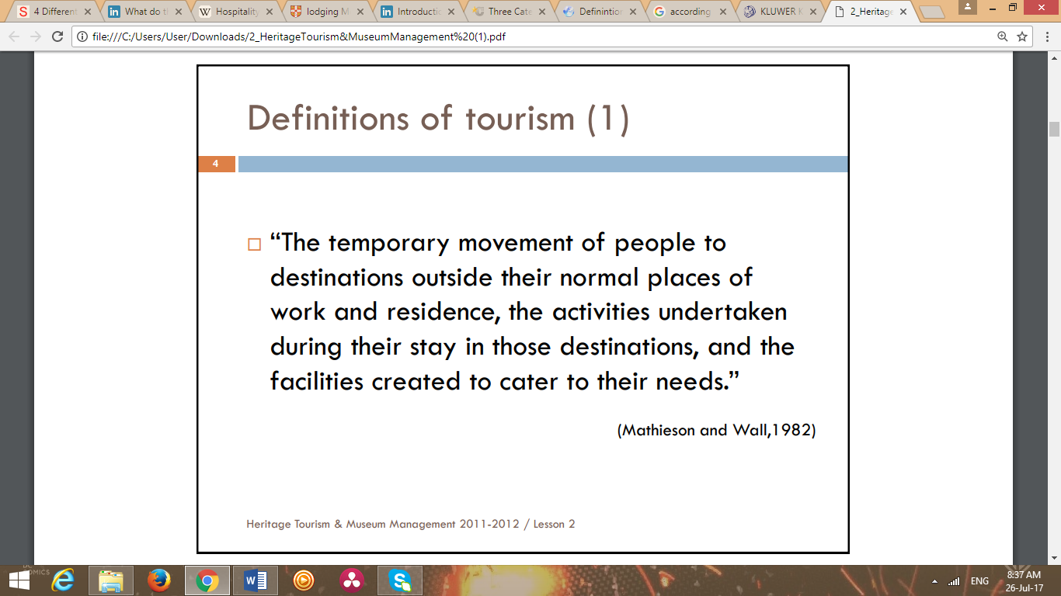

Appendix 3.2

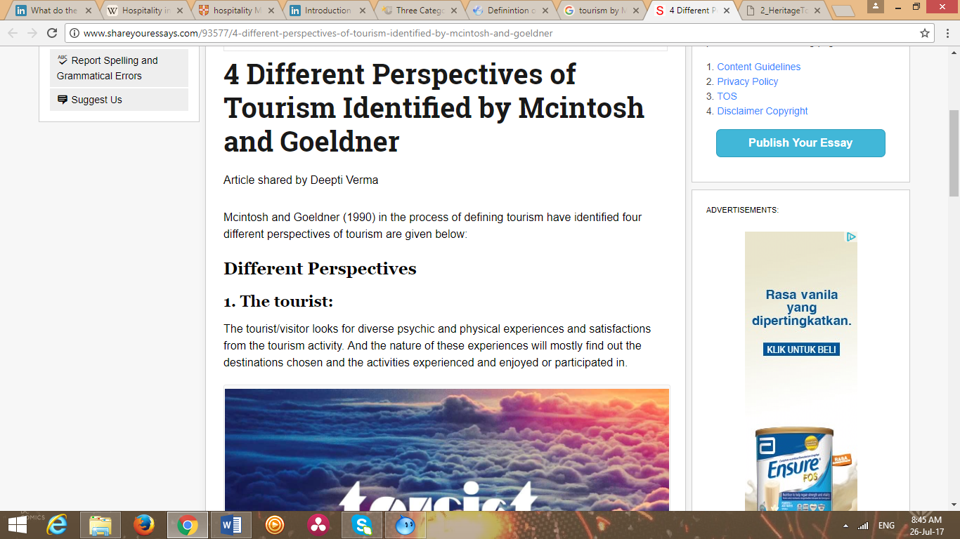

Appendix 3.3

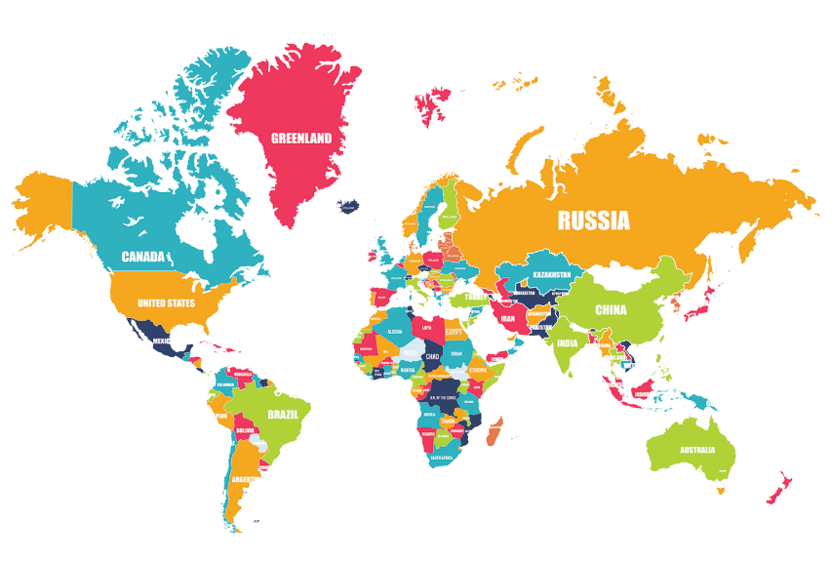

Appendix 3.4

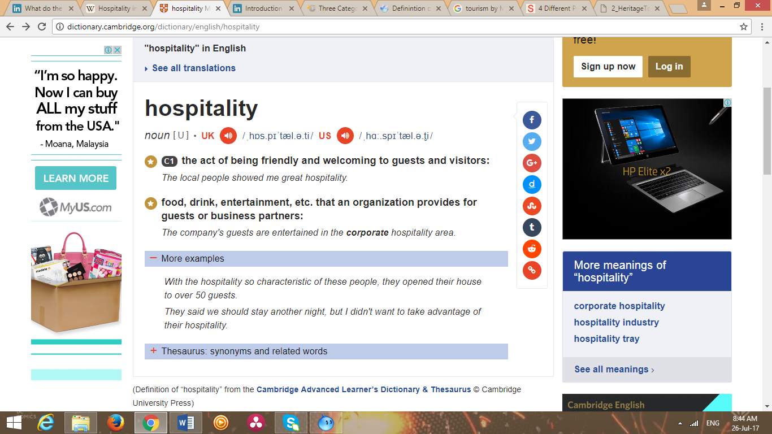

Appendix 3.5

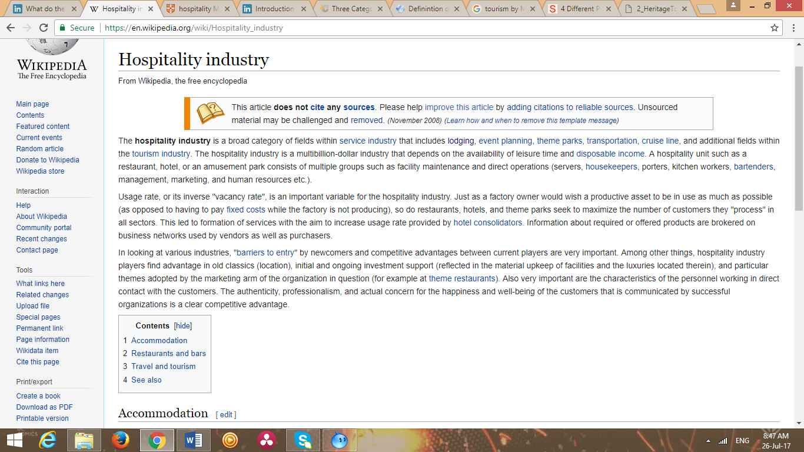

Appendix 3.6

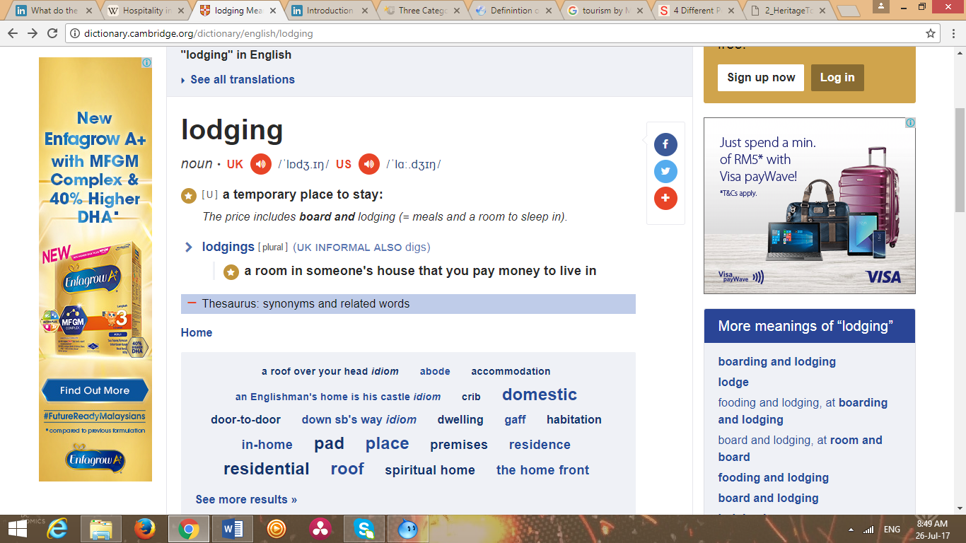

Appendix 4.1

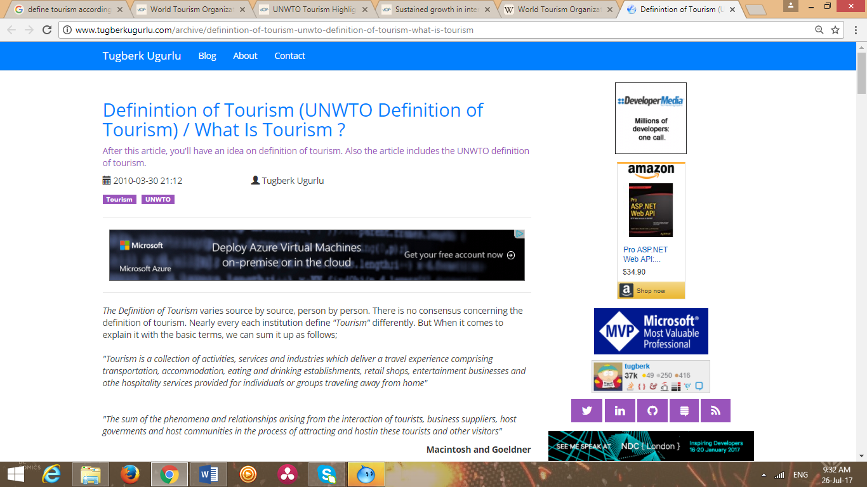

Appendix 4.2

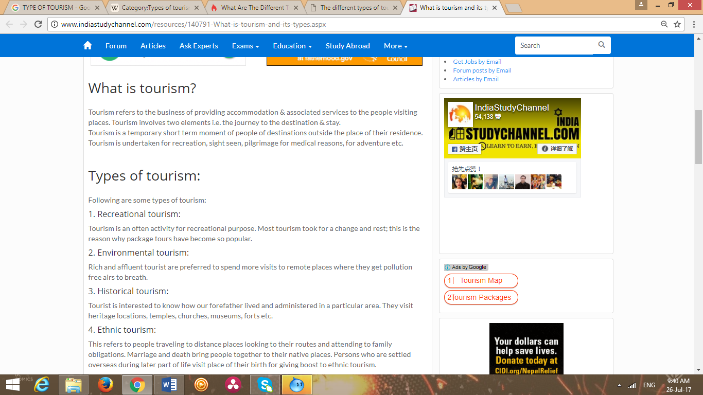 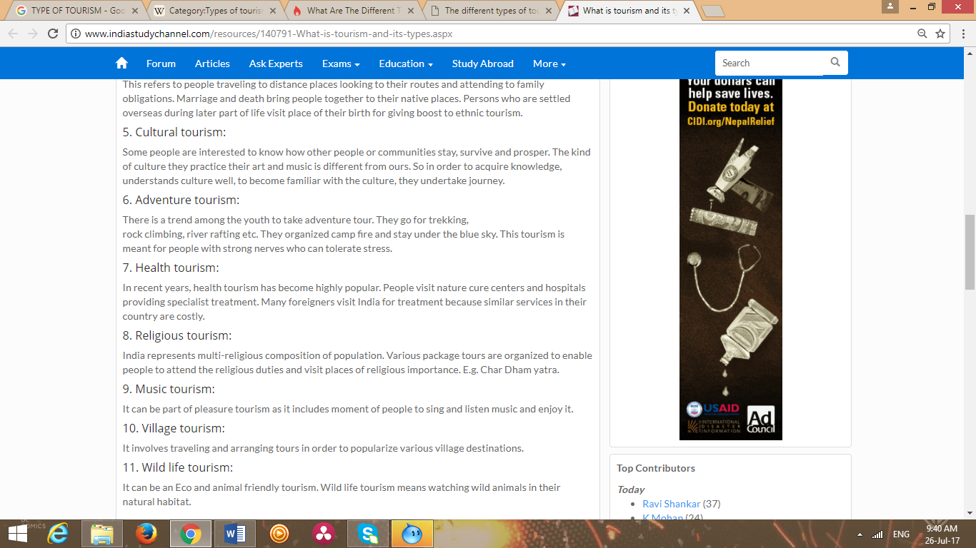

Appendix 5.1

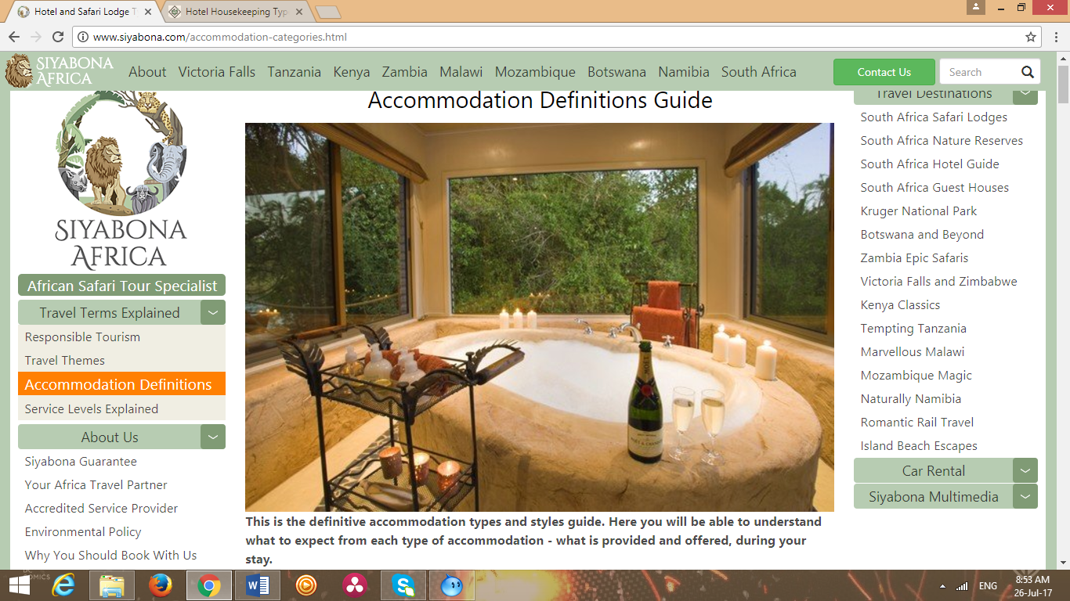

Appendix 5.2

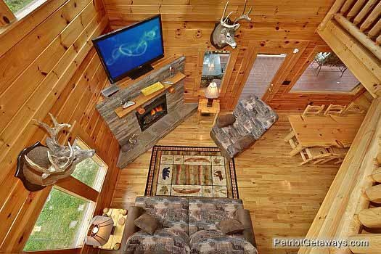

Appendix 5.3

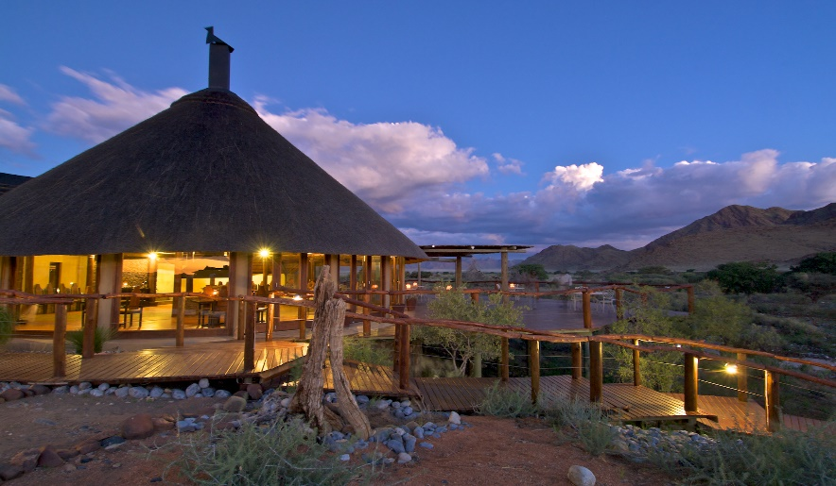

Appendix 5.4

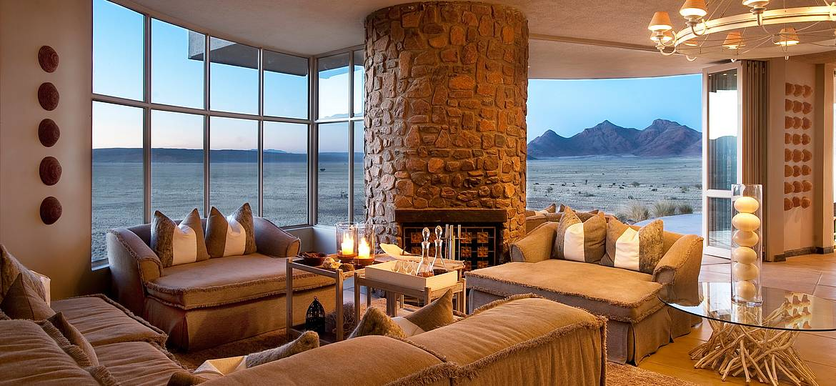

Appendix 5.5

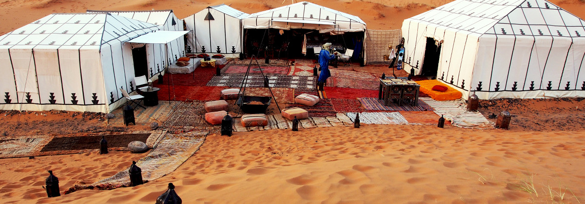

Appendix 5.6

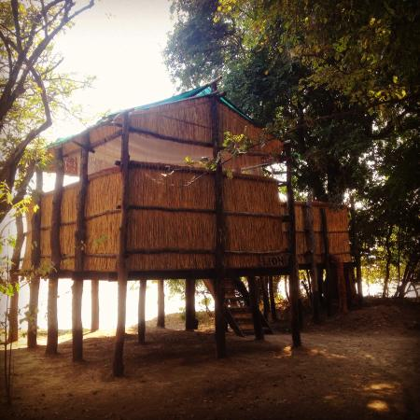

Appendix 5.7

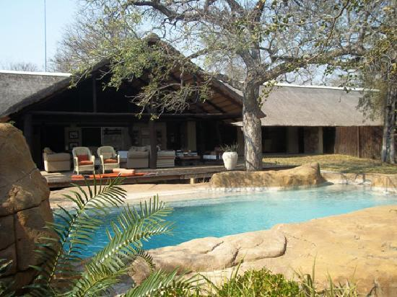

Appendix 5.8

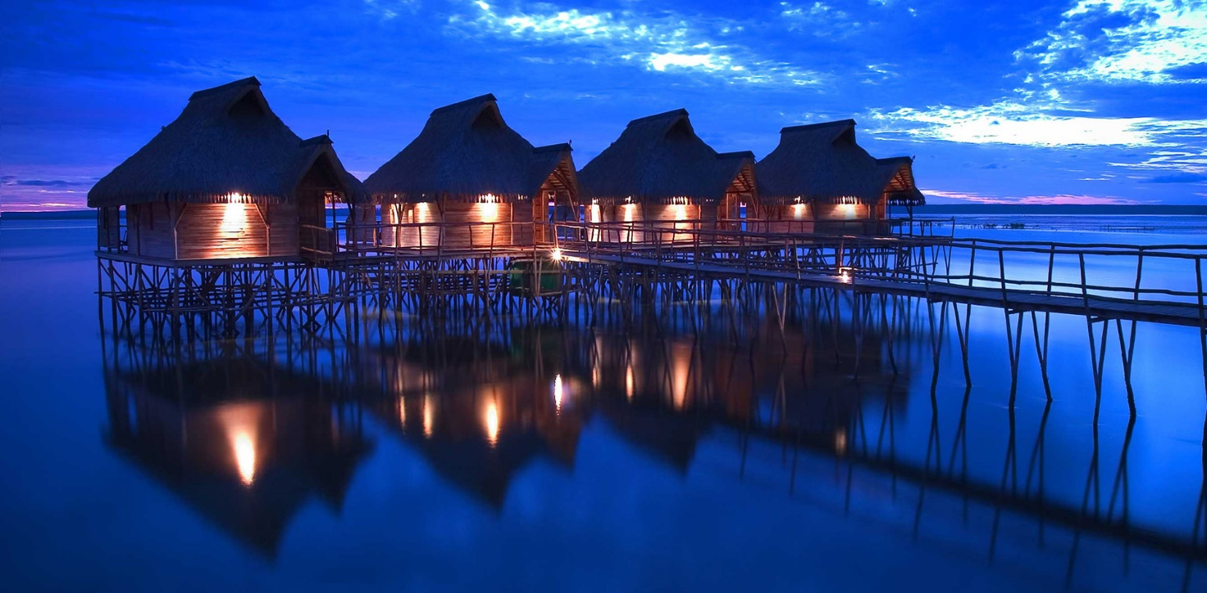

Appendix 5.9

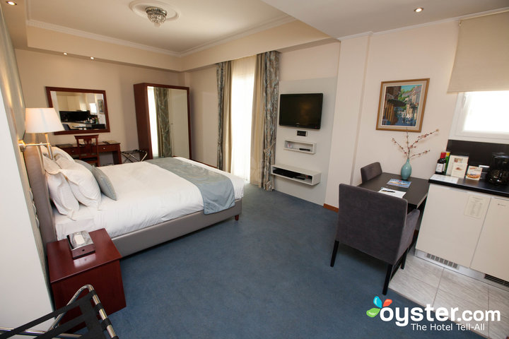

Appendix 5.10

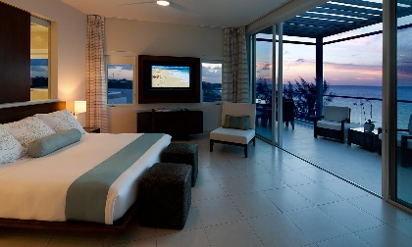

Appendix 5.11

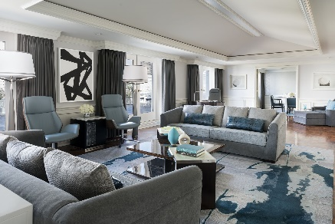

Appendix 5.12

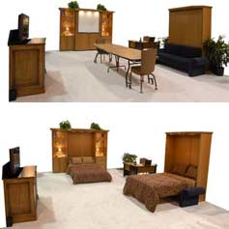

Appendix 5.13

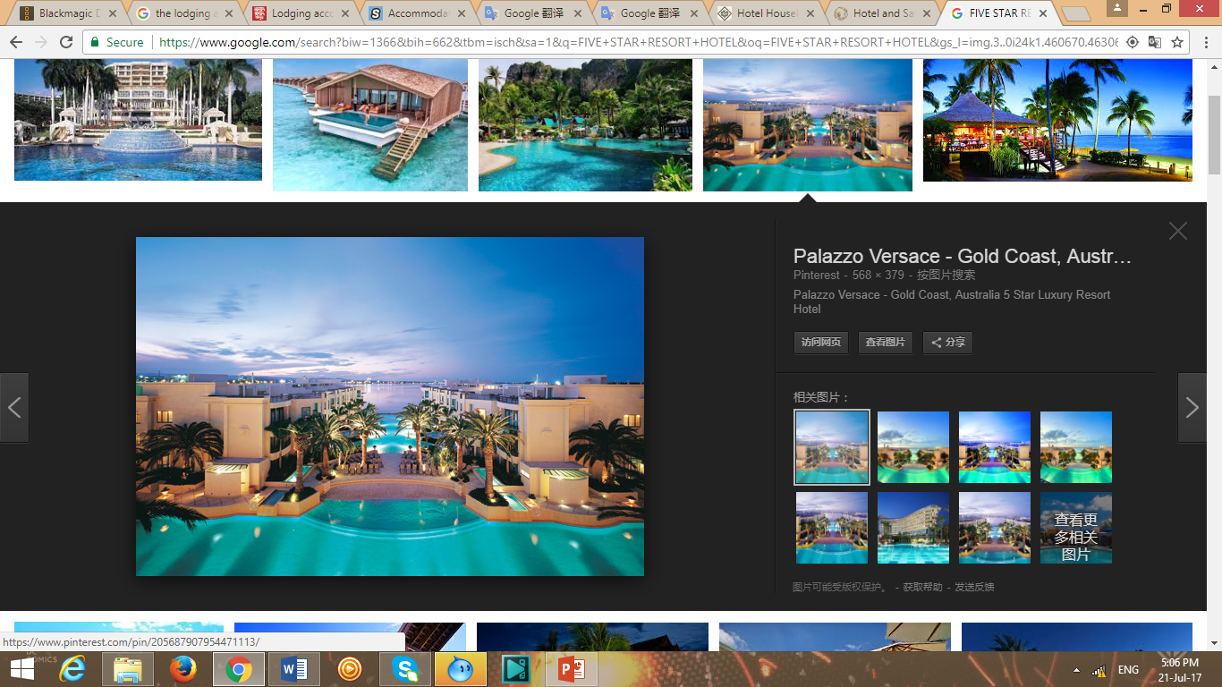

Appendix 5.14

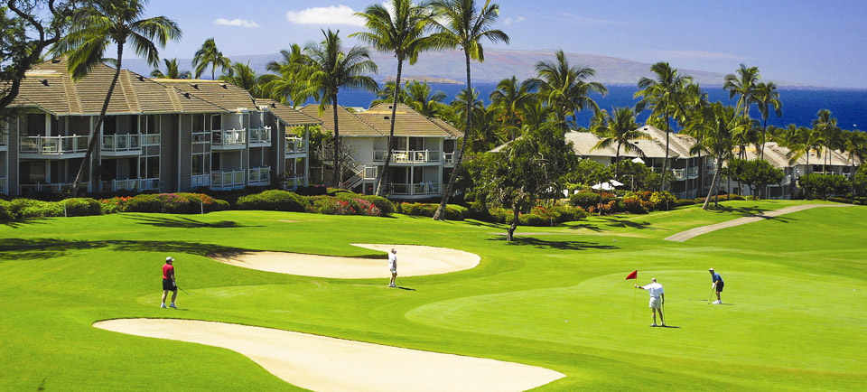

Appendix 5.15

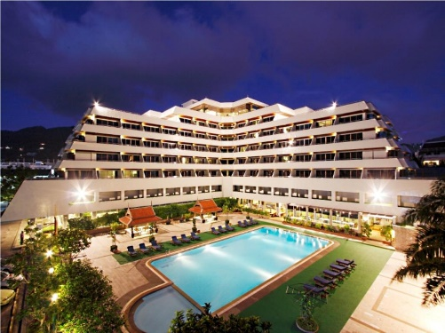

Appendix 5.16

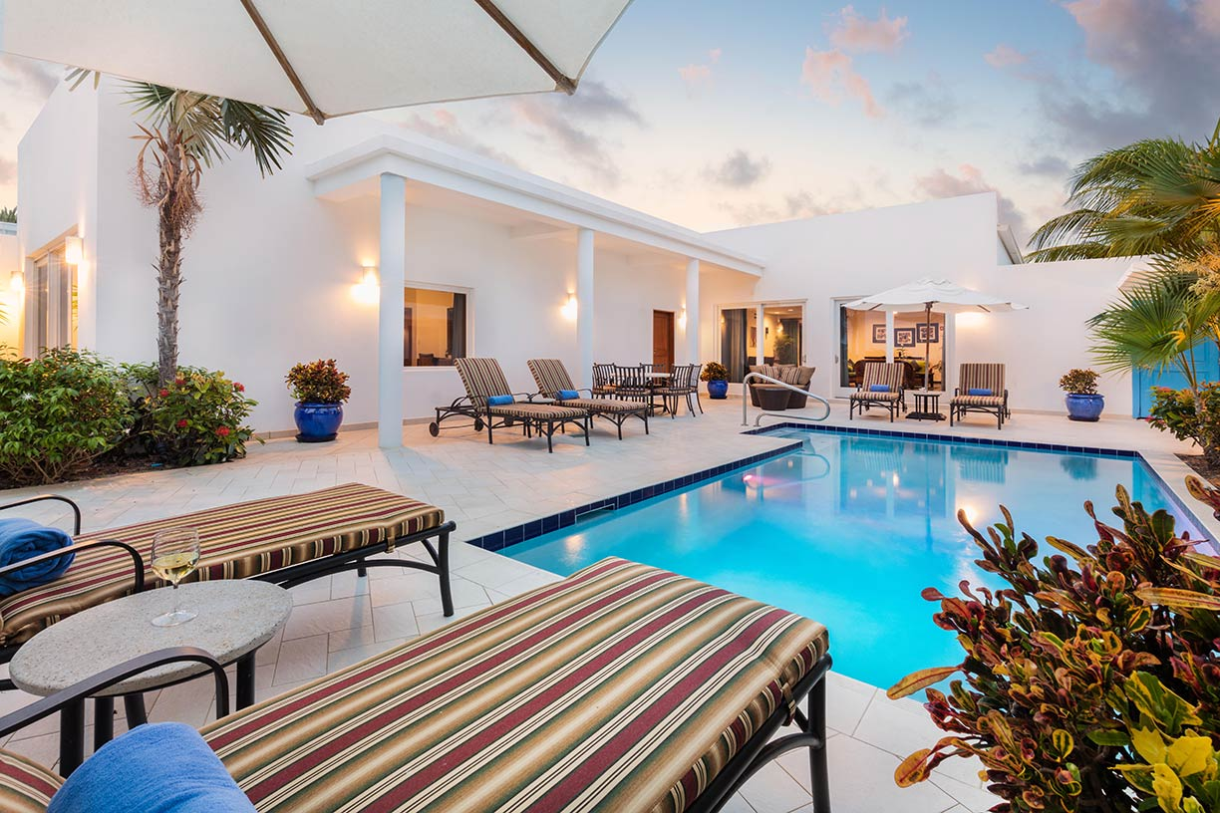

# **References**

*Accommodation Definitions Guide*. (2017). Retrieved from Siyabona Africa: http://www.siyabona.com/accommodation-categories.html

Calahan, M. (2014, OCT 16). *What do the words hospitality and customer service mean to you?* Retrieved from Linkin: https://www.linkedin.com/pulse/20141016155813-131795743-what-do-the-words-hospitality-and-customer-service-mean-to-you

Corporation, C. (2003-2017). *Whatis alternative tourism?* Retrieved from wiseGEEK: http://www.wisegeek.com/what-is-alternative-tourism.htm

heraesquivel. (2014, OCT 7). *Introduction to Hospitality Industry*. Retrieved from SlideShare: https://www.slideshare.net/heraesquivel/introduction-to-hospitality-industry-39956160

*Hospitality industry*. (2017). Retrieved from WIKIPEDIA: https://en.wikipedia.org/wiki/Hospitality_industry

*Meaning of "entertainment"*. (2017). Retrieved from Oxford University Press: https://en.oxforddictionaries.com/definition/entertainment

*Meaning of “lodging"*. (2017). Retrieved from Cambridge University Press: http://dictionary.cambridge.org/dictionary/english/lodging

Moskowitz, K. (2017). *Why is entertainment important?* Retrieved from Reference: https://www.reference.com/world-view/entertainment-important-678f1221f7256bf

Reynolds, M. (2017). *Three Categories of the Hospitality Industry*. Retrieved from Chron: http://smallbusiness.chron.com/three-categories-hospitality-industry-58524.html

Ross, S. D. (2001, July). *DEVELOPING SPORTS TOURISM* . Retrieved from http://www.lib.teiher.gr/webnotes/sdo/Sport%20Tourism/Sport-Tourism%20Development%20Guide.pdf

*Types of Hotels & Rooms*. (2017). Retrieved from TutorialsPointSIMPLYEASYLEARNING: https://www.tutorialspoint.com/hotel_housekeeping/types_hotels_and_rooms.htm

Ugurlu, T. (2010, March 30). *Definintion of Tourism (UNWTO Definition of Tourism) / What Is Tourism ?* Retrieved from Tugberk's Blog: http://www.tugberkugurlu.com/archive/definintion-of-tourism-unwto-definition-of-tourism-what-is-tourism

Verma, D. (2016). *4 Different Perspectives of Tourism Identified by Mcintosh and Goeldner*. Retrieved from Shareyouressays.net: http://www.shareyouressays.com/93577/4-different-perspectives-of-tourism-identified-by-mcintosh-and-goeldner